**Accessibility Report**

**Approach to conformance testing:**

Conformance testing is the process of ensuring that a website or application complies with accessibility standards and guidelines. The Web Content Accessibility Rules (WCAG), a set of rules for increasing web content accessibility for people with disabilities, are usually used as the definition for these standards.

I have approached conformance testing through three distinct methods:

To begin, automated testing scans and tests websites and applications for accessibility issues using software tools such as WAVE, Lighthouse, and Axe. These tools effectively detect flaws such as incorrect HTML structure, insufficient color contrast, and missing alt text.

Through manual testing, a human tester interacts with and navigates the website or application to identify accessibility issues. This manual method can detect subtleties that automatic tools might overlook, such as meaningful link text, keyboard accessibility, and logical tab order.

Finally, the checklist technique employs a comprehensive list of accessibility requirements, including the WCAG recommendations. This methodology ensures a rigorous and exhaustive review of every aspect of accessibility by painstakingly verifying that the website or application fits every criterion.

**Test results and Recommendations:**

**Accessibility issues and warnings were identified on the** [**home.html**](homePage/home.html) **page as follows:**

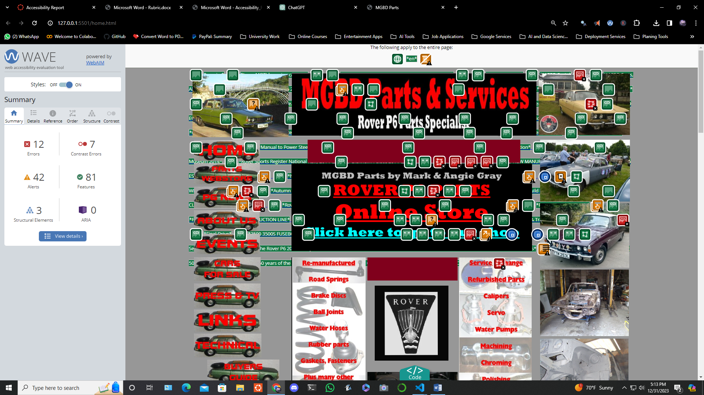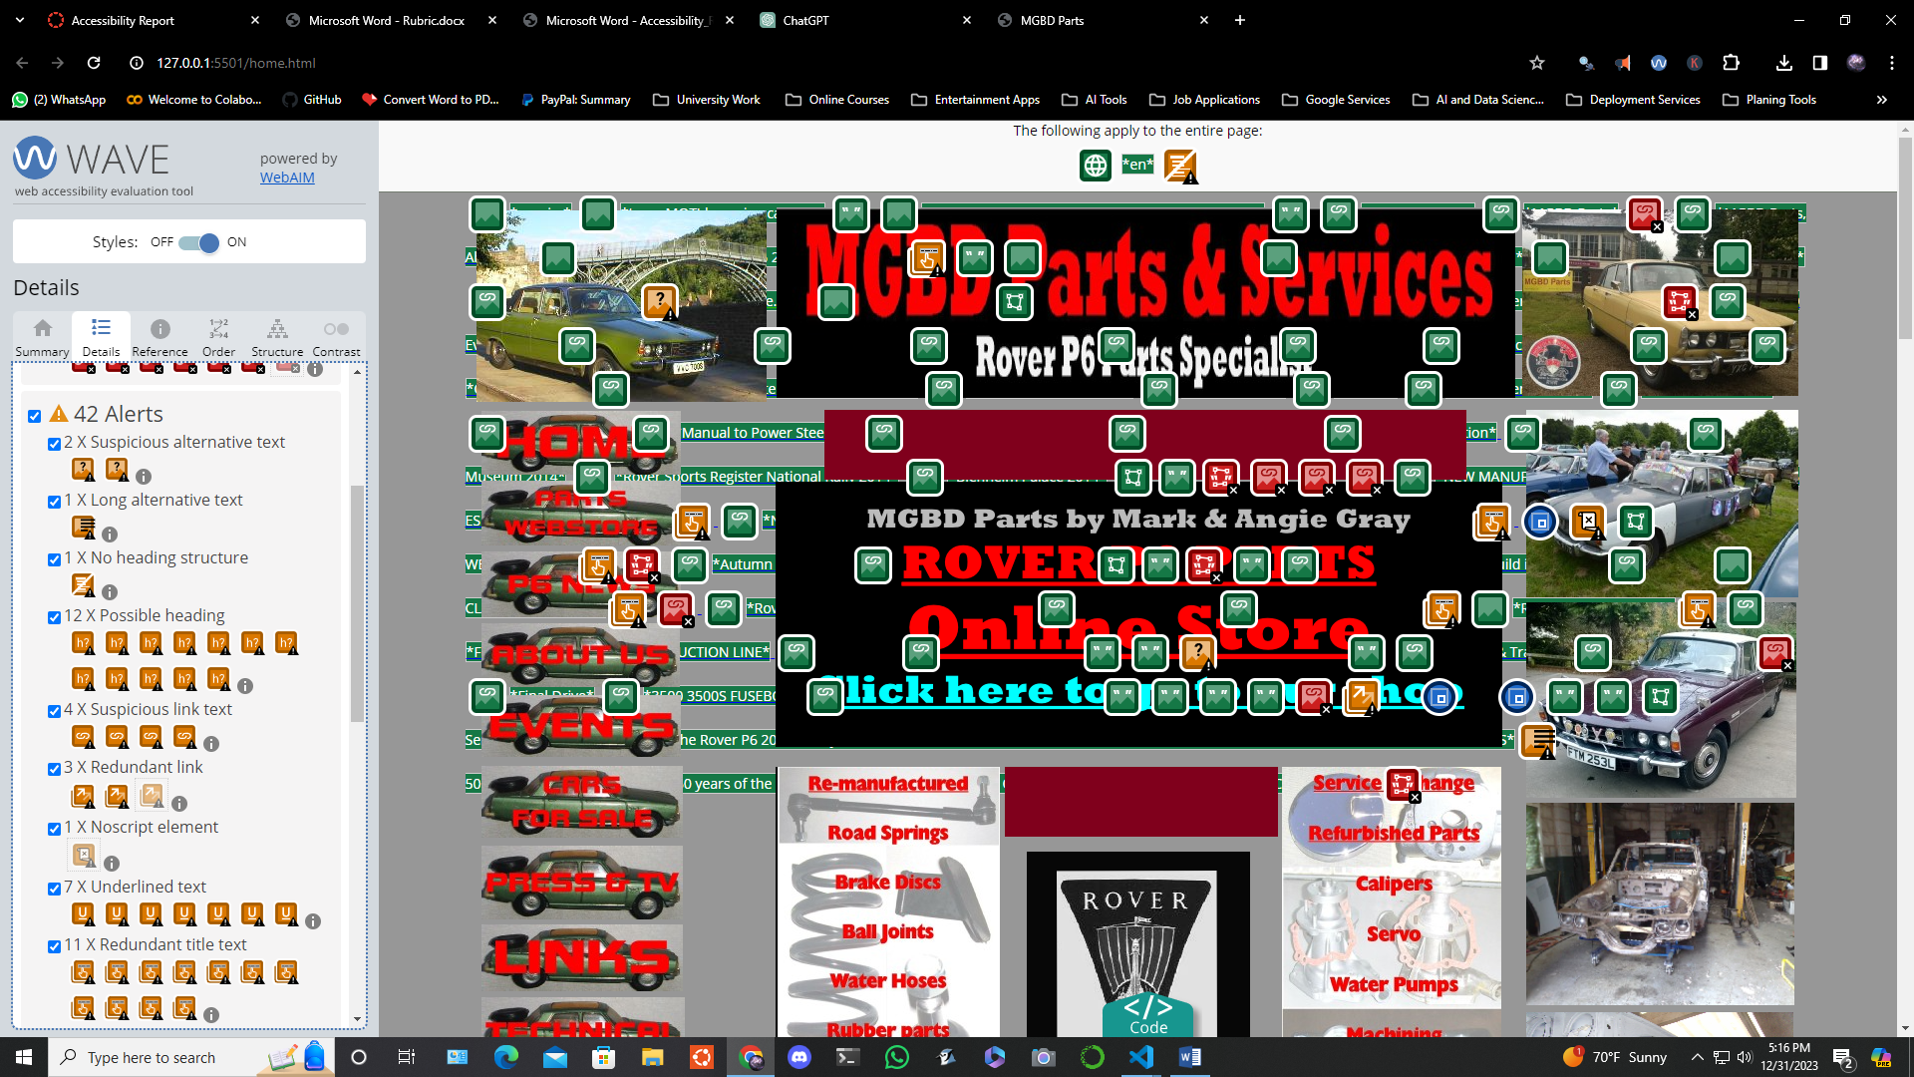

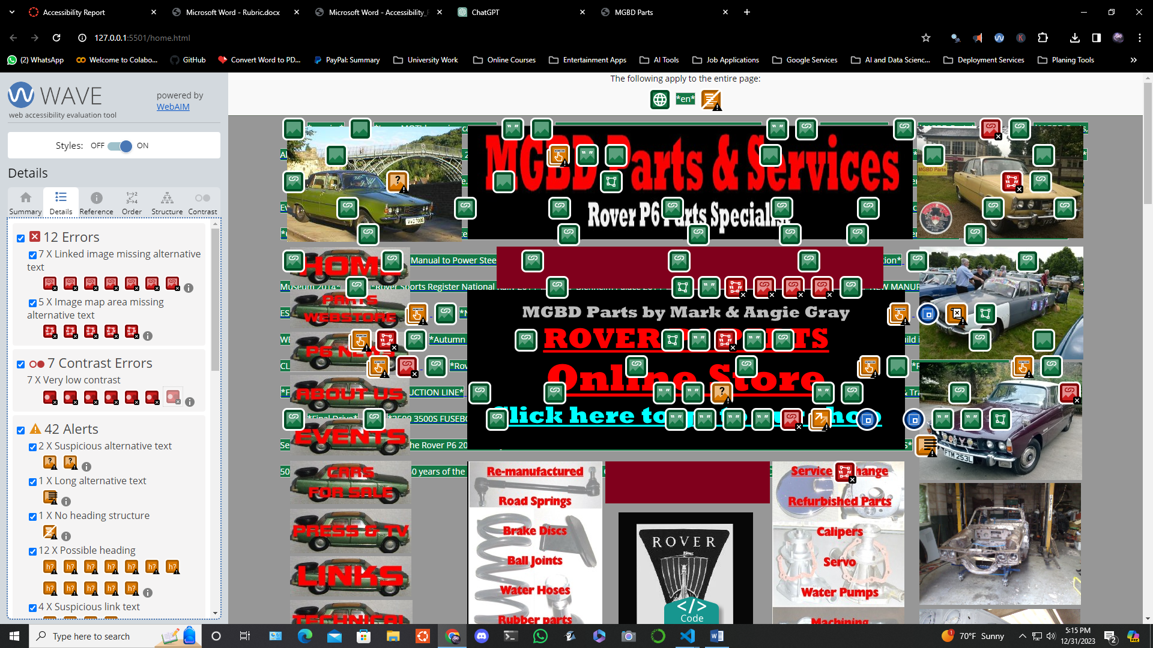

**12 Errors:**

**7 X linked image missing alternative text:**

This indicates that an image does not have alternative text, resulting in an empty link. It is critical to include descriptive alternative language for photos within links, especially if the link has no text. Screen readers cannot transmit the operation of the link to users without alternate text. To fix this, include relevant alternative text that appropriately reflects the image's content and/or the link's function.

**5 X image map area missing alternative text:**

In this scenario, replacement text for an image map location (hot spot) is missing. Image map sections or clickable hotspots provide crucial functionality, and replacement text is required for screen reader users or when images are not accessible. Add descriptive alt attribute values to each area element to remedy this issue. Additionally, ensure that the code's area elements are ordered logically and intuitively.

**7 Contrast Errors:**

**7 X Very low contrast: ­­**

This implies that the contrast between text and background colors is quite low, which is critical for users, especially those with limited eyesight. Increase the contrast between the foreground (text) and background colors to correct this. It's worth noting that larger text necessitates less contrast than smaller text.

**42 Alerts:**

**2 X Suspicious alternative text:**

This indicates that alternative text for photos may include insufficient or superfluous information. It is critical to ensure that the alternative text conveys the same information as the visual content. Avoid using generic alternative wording such as "image of..." and ensure that it accurately conveys the image's content and function.

**1 X Long alternative text:**

Images with extremely long alternative text are flagged. Alternative text should be brief and informative. Long alternative text (more than 100 characters) may suggest the presence of superfluous content. To remedy this, make sure the alternative text is brief and accurately reflects the image's content and function.

**1 X No heading structure:**

This shows the absence of headers, which are essential for document structure and navigation for users of assistive technology. To address this, establish a clear and consistent heading structure that includes at least one h1> and sub-headings if needed.

**12 X Possible heading:**

This indicates that the text looks to be a heading but does not contain a heading element. Use suitable header elements (h1>-h6>) for sections masquerading as headings to maintain content structure and assist assistive technology users.

**4 X Suspicious link text:**

Links containing confusing or unnecessary language can be perplexing, especially when read out of context. Rewrite the link wording to be more informative of its location, and remove any unnecessary material such as "click here."

**3 X Redundant link:**

Adjacent links to the same URL can cause users to navigate and repeat themselves. Combine duplicate links into one link if possible, deleting any unnecessary text or alternative wording.

**1 X Noscript element:**

The presence of a <noscript> element is indicated. As <noscript> cannot be depended on to generate an accessible version when JavaScript is deactivated, ensure that scripted content is accessible.

**7 X Underlined text:**

Typically, underlined text denotes connected text. Unless necessary, consider removing underlines from non-link content. To distinguish non-link content, use alternative formatting options (for example, bold or italics).

**11 X Redundant title text:**

The title attribute text is detected if it is identical to the text or alternative text. The title attribute is intended for advisory information only and should not be used to duplicate other content. To give distinct advisory information, modify or remove repetitive title text. It is important to note that title text may not be read by a screen reader and is often unavailable to sighted keyboard users.

**Accessibility issues and warnings were identified on the** [**shop.html**](shopPage/shop.html) **page as follows:**

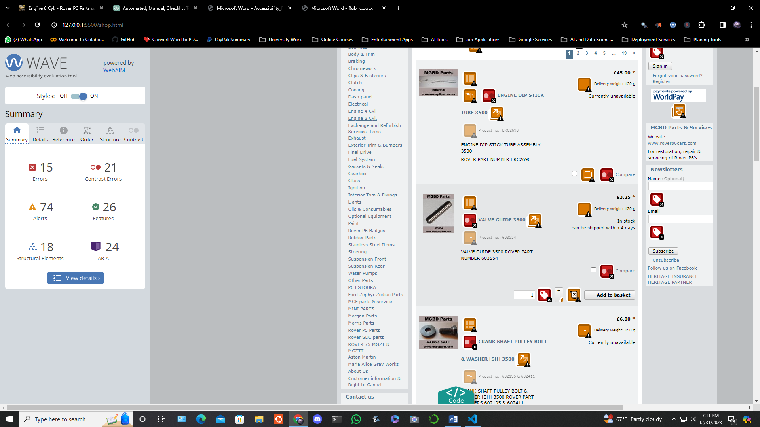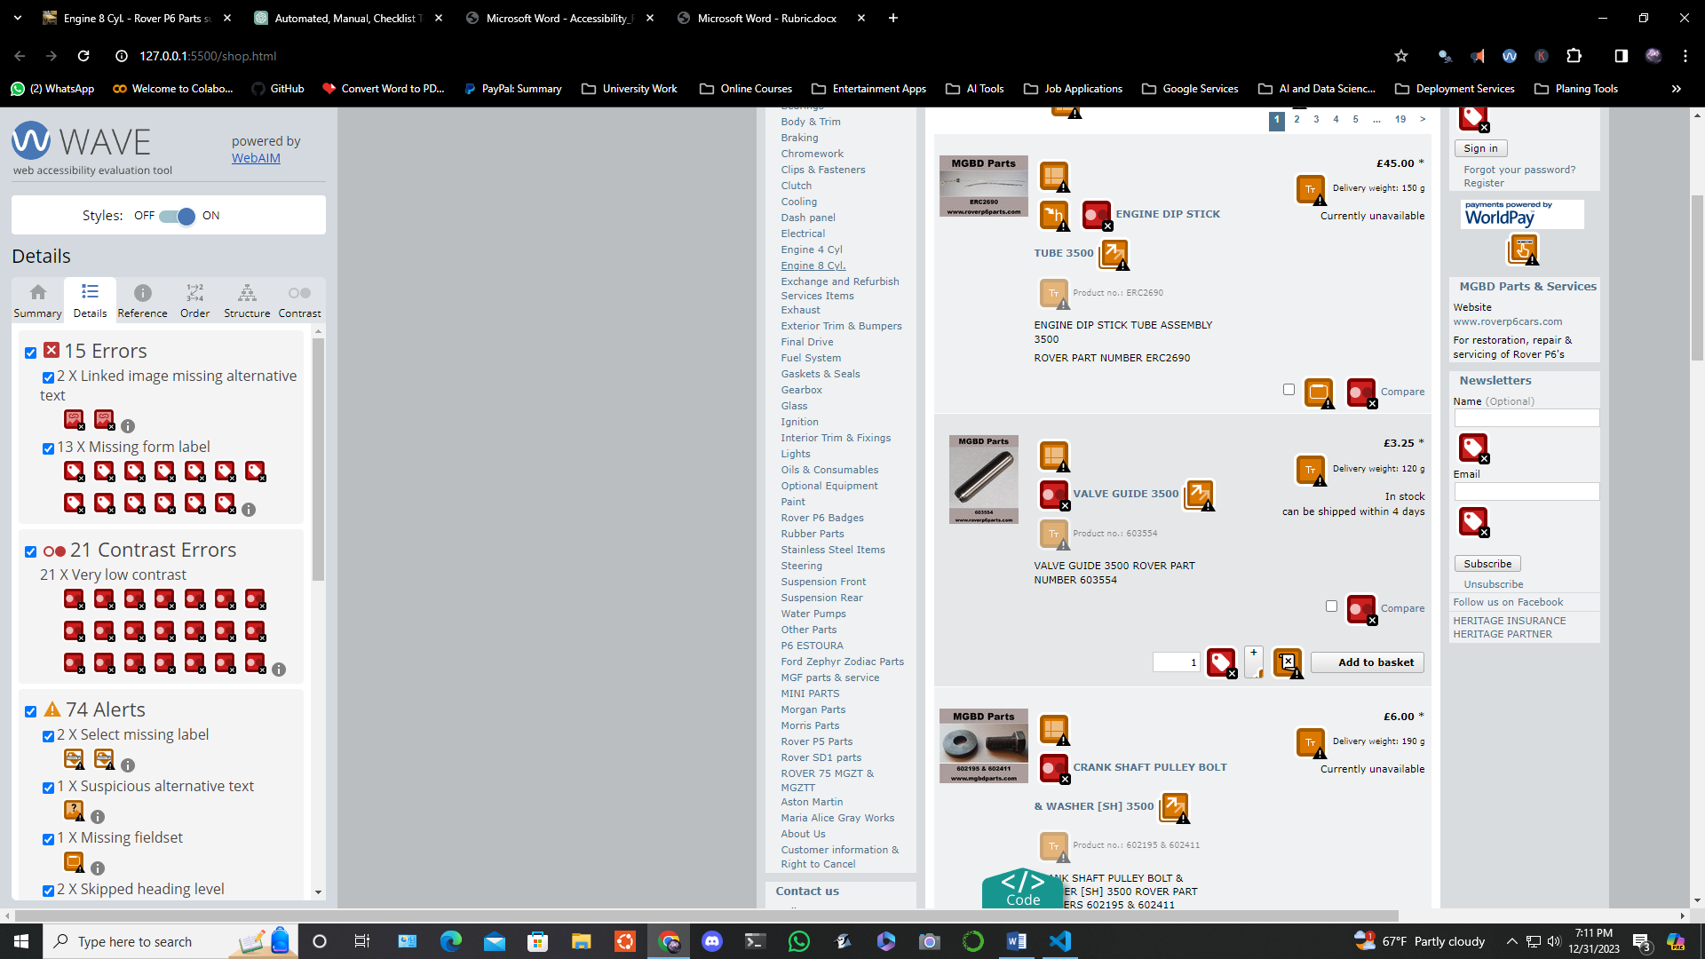

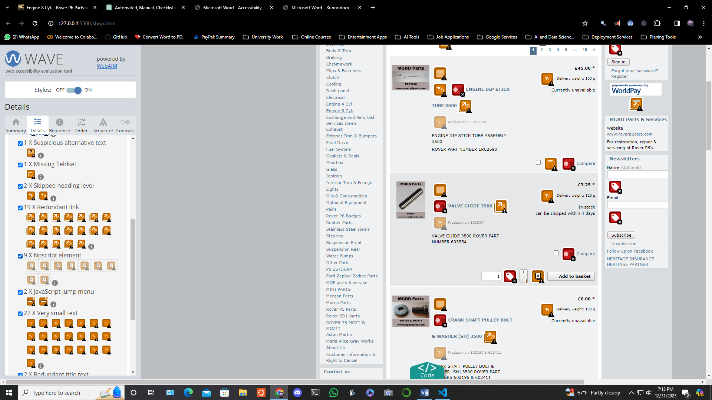

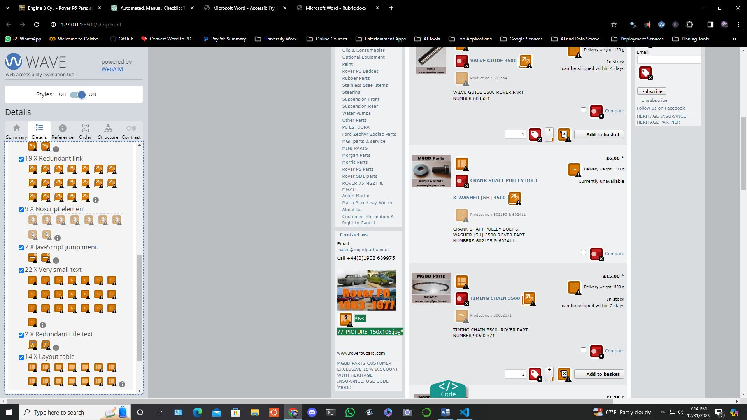

**15 Errors:**

**2 X Linked image missing alternative text:**

This means that certain photos are missing alternate text, resulting in empty links. It is critical to include descriptive alternative language for photos within links, especially if the link has no text. Screen readers cannot transmit the operation of the link to users without alternate text. To fix this, include relevant alternative text that appropriately reflects the image's content and/or the link's function.

**13 X Missing Form Label:**

This indicates that a form control does not have a label. This omission may make it difficult for screen reader users to grasp the purpose of the form control. Form labels also improve visual explanations and make form controls more clickable. To correct this, use the label> element to associate visible label text with its corresponding form control. If no visible label exists, supply an associated label, provide a descriptive title property to the form control, or use aria-labeled to reference the label(s). It should be noted that certain form controls do not require labels.

**22 Contrast Errors:**

**21 X Very low contrast:**

This indicates relatively low contrast between text and background colours, which is especially important for users, particularly those with limited vision. Increase the contrast between the foreground (text) and background colours to correct this. It's worth noting that larger text necessitates less contrast than smaller text.

**74 Alerts:**

**2 X Select a missing label:**

A specific element that lacks a corresponding label can have an impact on users, particularly those who use screen readers. To fix this, make sure the menu's default option clearly states its function. Assign visible label text to the Choose menu if it exists.

**1 X suspicious alternative text:**

This indicates that alternative text for photos may include insufficient or superfluous information. It is critical to ensure that the alternative text conveys the same information as the visual content. Use brief yet equivalent alternatives instead of nonspecific alternative wording like "image of...".

**1 X Missing Fieldset:**

A collection of checkboxes or radio buttons without a fieldset can be confusing. Fieldsets offer visual and structural grouping, which is especially useful when a higher-level description (legend) is required. To address this, incorporate a legend element and mark up the group within a fieldset.

**2 X skipped heading level:**

Users who rely on assistive technology may be confused if heading levels are skipped. Reorganize document headings to maintain a logical arrangement.

**19 X Redundant Link:**

Adjacent links to the same URL cause people to navigate and repeat themselves. Combine duplicate links into one link if possible, deleting any unnecessary text or alternative wording.

**9 X Noscript element:**

The presence of a <noscript> element is indicated. As noscript> cannot be depended on to generate an accessible version when JavaScript is deactivated, ensure that scripted content is accessible.

**2 X JavaScript jump menu:**

A JavaScript jump menu that uses the on-change event to change pages may obstruct keyboard navigation. Remove the JavaScript jump menu if appropriate and allow users to change the select menu by pressing an adjacent button to initiate the new page.

**22 X Very small text:**

Very small text is difficult to read, especially for individuals with limited vision. Increase the text size to improve readability.

**2 X Redundant title text:**

The title attribute text is detected if it is identical to the text or alternative text. To give distinct advisory information, modify or remove repetitive title text.

**14 X Layout table:**

The presence of layout tables, which are utilised for visual positioning, can cause problems with reading and navigation order. For visual appearance, replace layout tables with relevant HTML elements and CSS. If a layout table remains, maintain logical reading and navigation order and assign it the role="presentation" to prevent screen readers from mistaking it for a data table.